# DVM1 Horse Handling and Restraint

# Session 1

## Learning outcomes:

At the end of this practical students should:

* Know the correct procedure for safely approaching and releasing a horse in a yard
* Be able to catch a horse, fit and secure a halter and lead a horse
* Identify and appropriately use grooming equipment

### Preparation

For the horse handling practical classes we will work on our basic horse handling skills to prepare you for the safety assessment. Please review the material below prior to attending the practical class.  Throughout these sessions you will complete the same tasks that you did on the simulators but on the live animal.  The clinical skills booklets are good references to review prior to attending the practical classes.

Watch these videos:

Approaching a horse- <https://youtu.be/QK8McC1qvp0>

Applying a head collar- <https://youtu.be/IRjBch9I4_8>

Leading a horse- <https://youtu.be/AsP38UPNHvI>

Releasing a horse- <https://echo360.net.au/media/41b9d0b7-6bcc-48de-8050-61aaf9f17aa4/public>

Grooming equipment- <https://youtu.be/QV-ZJ9KJ0T0>

*\*Picking up feet will be performed in session 3*

### Approaching a horse and applying a head collar

Safe horse handling practices and general aspects relating to the behaviour and handling of horses will be addressed during this practical.

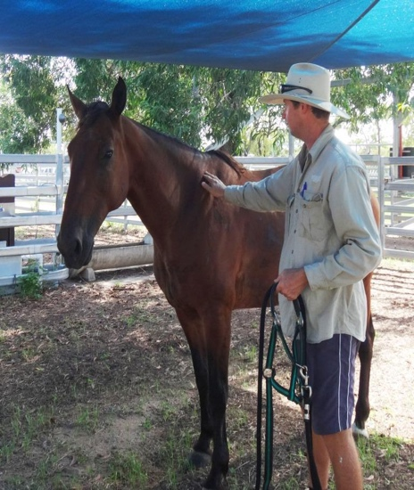

Prepare your head collar.

1. Have the neck strap buckle open, nose strap buckle closed and lead rope attached to the correct buckle and held in your hand.​
2. Approach the horse from the LEFT side.
3. Place lead rope around horse’s neck.
   * Be careful to gently place the lead rope, do not throw it.  
     ​

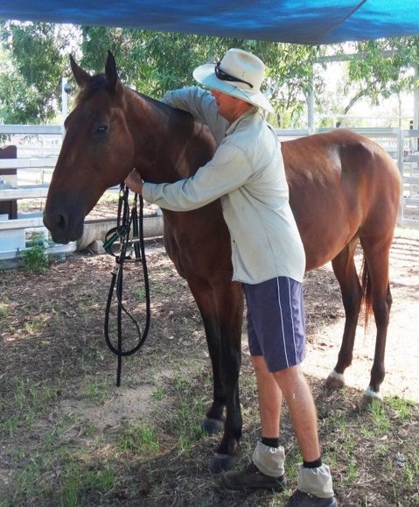 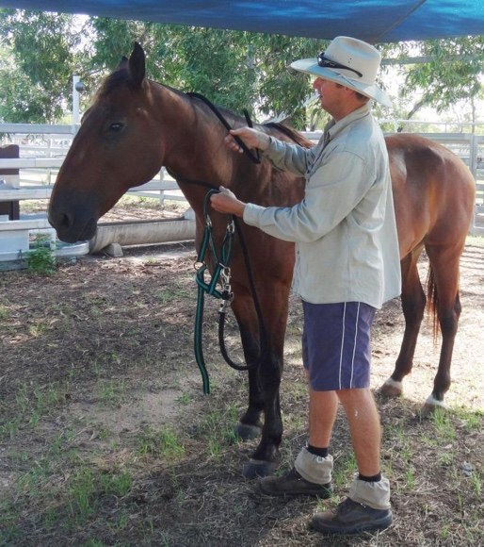

*\*If it is not possible to approach at the LEFT shoulder, you may approach the RIGHT shoulder to place the lead rope and then move to the left side to place the head collar.*

4. Hold both ends of the lead rope to control of the horse and if you need to move from the right to the left side around the front of the horse.

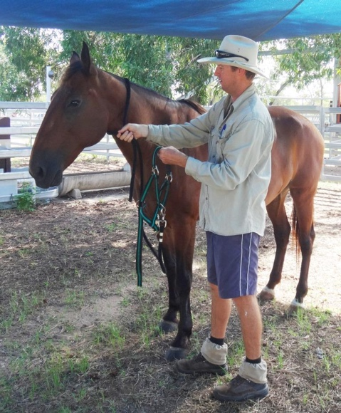

5. Place the neck strap around the horse’s neck by passing your right arm over the horse’s neck and passing the halter under the horse’s neck with the left hand.

6. Grasp the head strap of the halter with the right hand.

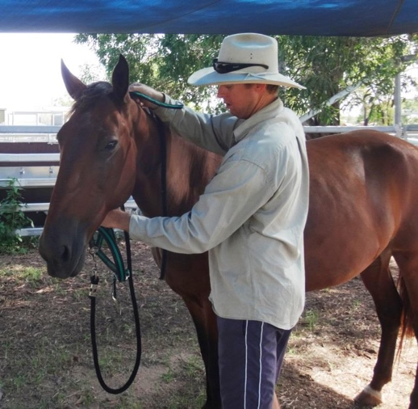

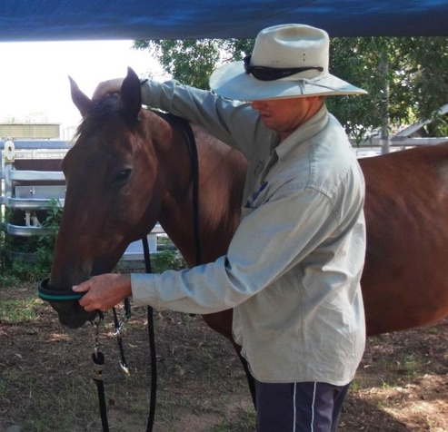 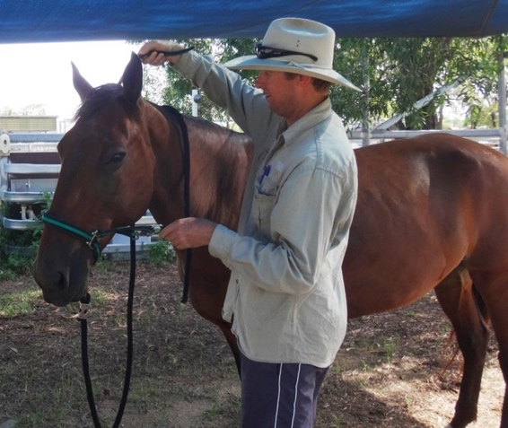

7. Slide the nose piece over the horse’s nose using your left hand and ease the halter onto the horse’s head.

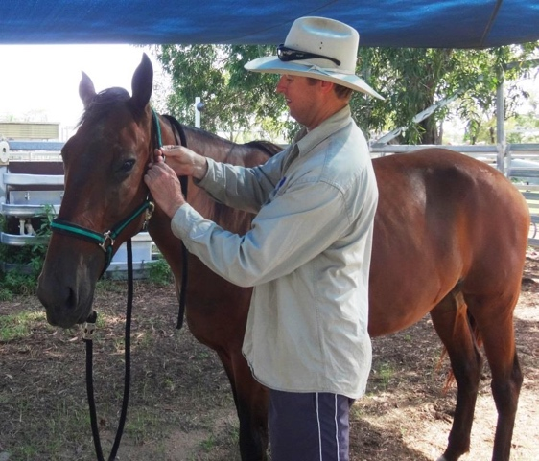

8. Ensure the head strap is sitting directly behind the horses' ears and secure the neck strap through its buckle.

*\*When fit appropriately the nose piece should sit two fingers below the facial crest and the throat latch should roughly fit four fingers underneath it to ensure it is not too tight.*

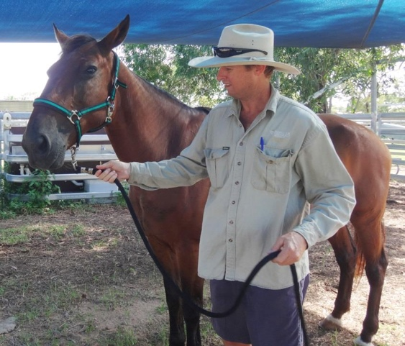

9. Have both hands on the lead rope, the right hand near the buckle. (Do not put fingers through the ring).

The left hand should hold the rope further down, ensuring it is not wrapped around the hand.

10. You are now ready to lead the horse around the yard.

### Leading a horse

1. Standing on the left-hand side (near side) of the horse, hold the lead rope just below the snap with your right hand.
2. Hold the end of the lead rope folded to fit comfortably in your left hand. Hold around the middle of the folds so that there are no loops around your hand.
3. Stand at the horse's shoulder.
4. Cue the horse to walk with a slight forward motion of your right hand on the lead rope and walk forward yourself.
5. Stop by stopping yourself and pulling back lightly on the lead rope. The horse should stop and stand beside you.
6. Ask your horse to back up by turning around to face it. Take the lead rope in your left hand, and with your right-hand point at or press on the horse's left shoulder and pull down and back slightly with the lead rope. Step forward yourself to stay with your horse as it steps back.

### Releasing a horse in a yard

1. Position your horse 3-5 metres from the gate with the left side of the horse facing the gate so that your body is positioned between the horse and the gate.

2. Unbuckle the head piece and remove the head collar, you do not need to place the lead rope around the horse’s neck as you did when you applied the head collar.

3. Walk towards the gate keeping an eye on the horse. If the horse follows you continue to move calmly towards the gate and exit remembering to lock the gate behind you.

4. If the gate opens both ways it is preferred to open the gate inwards to prevent the horse rushing out after you.

5. Hang up head collar and lead rope neatly on gate or hook.